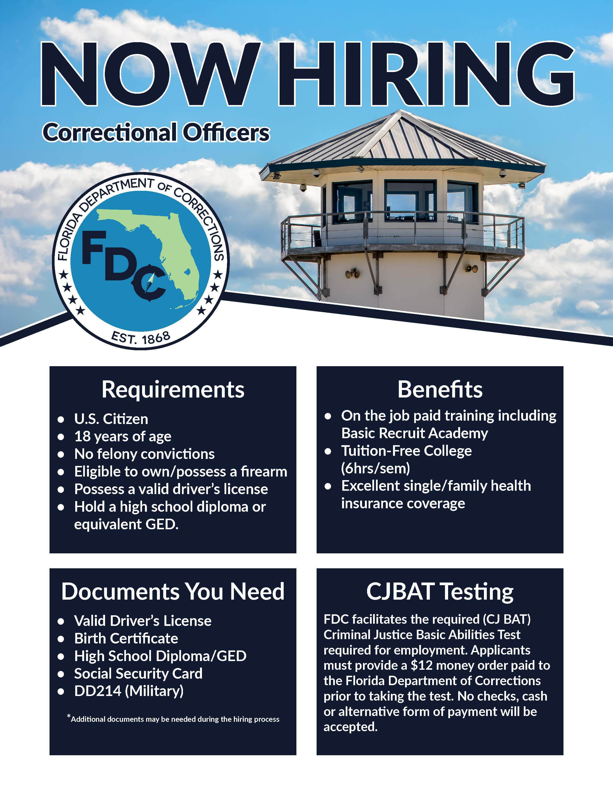



**Institutions:**

Northwest Florida Reception Center is located 20 minutes North of Lynn Haven on Hwy 77.

$1,000 Sign on Bonus available with completion of training and passing of the State Board Exam.

**For more information on career opportunities with the Florida Department of Corrections visit** [**www.fldocjobs.com**](http://www.fldocjobs.com) **or contact a local Recruiter directly:**

Sergeant George Lee

Northwest Florida Reception Center

4455 Sam Mitchell Dr

Chipley, FL. 32428

Phone**: 850-773-0315**

Email: [GeorgeS.Lee@fdc.myflorida.com](mailto:GeorgeS.Lee@fdc.myflorida.com)

|  |  |  |  |  |  |  |  |
| --- | --- | --- | --- | --- | --- | --- | --- |
| |  |  |  |  |  |  | | --- | --- | --- | --- | --- | --- | | |  | | --- | |  | |  | |  | |  | |  | | |  |

**Salary Information**:

**Biweekly Non-Certified**: $1,159.63

* Annual Salary: $30,150.38
* Hourly Salary: $14.49

**Biweekly Certified**: $1,288.47

* Annual Salary: $33,500.22
* Hourly Salary: $16.10

**Benefits: (Yearly)**

* Annual Leave = (104 hours)
* Sick leave = (104 hours)
* Military Leave = (240 hours)
* 9 State holidays and 1 Personal Holiday

**Health Insurance**

* Family ($180 monthly)
* Individual ($50 monthly)
* Supplemental Dental, Disability, Hospital, Life and Vision.

**Incentives**

* Tuition-Free College courses (State of Florida Colleges and Universities)
* Special Risk Retirement
* Promotional Opportunities
* Uniforms issued with Bi-annual uniform allowance
* Career Development Courses (Salary incentive)

**Training with FDC**

FTO – Onboard Program – 120 hours

Paid Basic Recruit Academy – 11 weeks